EXP – 1

-- Q1 create a table

CREATE TABLE EMP(

EMPNO INTEGER PRIMARY KEY,

ENAME varchar2(20) NOT NULL,

JOB varchar2(20) NOT NULL,

DEPTNO INTEGER,

SAL INTEGER

);

-- insert some values

INSERT INTO EMP VALUES (1, 'E1', 'SWE', 'Cloud', 2000000);

INSERT INTO EMP VALUES (2, 'E2', 'SWE', 'Cloud2', 3000000);

-- Q2 Add a column experience to the emp table

ALTER TABLE EMP ADD EXP INTEGER;

-- Q3: Modify the column width of the job field of emp table.

ALTER TABLE EMP modify(JOB varchar2(30));

INSERT INTO EMP values (2, 'E2', 'SWE', 'Blockchain', 300000, 2);

-- fetch some values

-- Q4: Create dept table.

CREATE TABLE EMP(

DEPTNO INTEGER PRIMARY KEY,

DNAME varchar2(10)

LOC varchar2(20),

);

-- Q5: drop a column experience to the emp table.

Alter table EMP drop column EXP;

-- Q6: Truncate the emp table and drop the dept table.

Drop table DEPT;

Truncate table EMP;

EXP - 2

-- Q1. Create a table called EMP with the following structure.

-- Name Type

-- ---------- ----------------------

-- EMPNO NUMBER

-- ENAME VARCHAR2(20)

-- JOB VARCHAR2(10)

-- DEPTNO NUMBER

-- SAL NUMBER

-- Allow NULL for all columns except ename and job.

CREATE TABLE EMP (EMPNO INTEGER, ENAME VARCHAR(20) NOT NULL,

JOB VARCHAR(10) NOT NULL,

DEPTNO INTEGER, SAL INTEGER);

-- Q2: Insert the following record into emp table using insert command:

-- 1 Mathi AP 1 10000

-- 2 Arjun ASP 2 12000

-- 3 Gagan ASP 1 12000

-- 4 Karthik Prof 2 30000

-- 5 Akalya AP 1 10000

-- 6 suresh lect 1 8000

INSERT INTO EMP VALUES ('1','Mathi','AP','1','10000');

INSERT INTO EMP VALUES ('2','Arjun','ASP','2','12000');

INSERT INTO EMP VALUES ('3','Gagan','ASP','1','12000');

INSERT INTO EMP VALUES ('4','Karthik','Prof','2','30000');

INSERT INTO EMP VALUES ('5','Akalya','AP','1','10000');

INSERT INTO EMP VALUES ('6','suresh','lect','1','8000');

SELECT \* FROM EMP;

-- Q3: Update the emp table to set the salary of all employees to Rs15000/- who are working as ASP .

UPDATE EMP SET SAL = 15000 WHERE JOB = 'ASP';

SELECT \* FROM EMP;

-- Q4: Delete only those who are working as lecturer

DELETE FROM EMP WHERE JOB = 'lect';

SELECT \* FROM EMP;

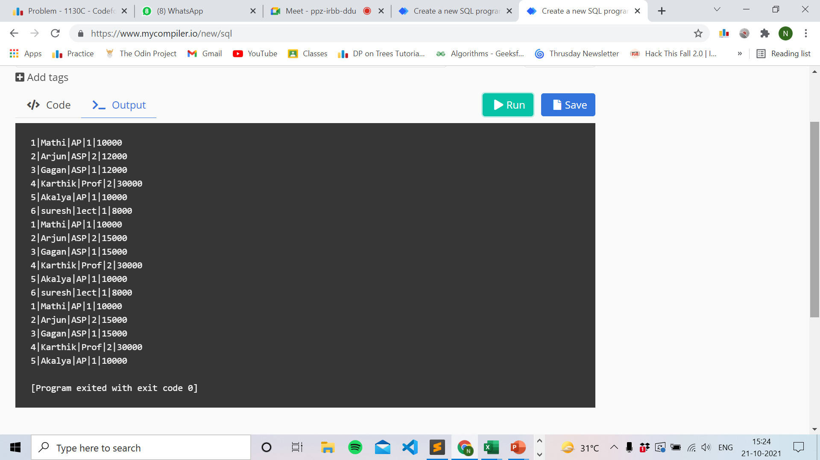

EXP – 3

-- Q1. Create the below table:

-- CUSTOMER TABLE with the following columns:

-- ID, NAME, AGE, ADDRESS and SALARY

-- Note: Add constraint primary key to ID column, not null to name column, check constraint to age with more than 22years.

CREATE TABLE students (

id INTEGER PRIMARY KEY,

name TEXT NOT NULL,

address TEXT,

age INTEGER CHECK (age >= 22)

);

EXP – 4

-- Q2. Insert the following records in the table:

-- ID NAME AGE ADDRESS SALARY

-- 1 Akshay 25 Delhi 30000

-- 2 Manish 27 Mumbai 35000

-- 3 Kushagra 26 Kolkata 30000

-- 4 Mukesh 31 Hyderabad 32000

-- 5 Himanshu 29 Chennai 40000

-- 6 Neeraj 30 Noida 36000

-- 7 Nishant 32 Delhi 30000

-- Q3: Write a query to find the salary of a person where age is <= 26 and salary >= 25000 from customer table.

-- Q4: Write a query to select distinct address in the table.

-- Q5: Update the record having address Chennai with age 20.

create table customer (

id integer primary key,

name varchar(255) NOT NULL,

age integer,

address text,

salary integer

);

insert into customer values (1, 'Akshay', 25, 'Delhi', 30000);

insert into customer values (2, 'Manish', 27, 'Mumbai', 35000);

insert into customer values (3, 'Kushagra', 26, 'Kolkata', 30000);

insert into customer values (4, 'Himanshu', 29, 'Chennai', 40000);

insert into customer values (6, 'Neeraj', 30, 'Noida', 36000);

insert into customer values (7, 'Nishant', 32, 'Delhi', 30000);

select salary from customer where salary >= 25000 and age <= 26;

select distinct address from customer;

select \* from customer;

update customer set age = 20 where address = 'Chennai';

select \* from customer;

